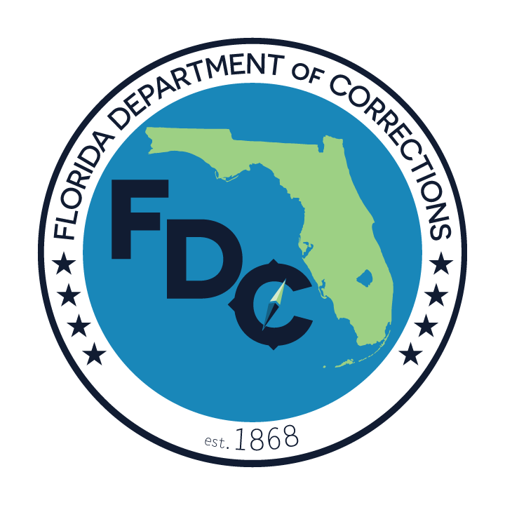

FLORIDA DEPARTMENT OF CORRECTIONS
NON-SECURITY STAFF INSTRUCTIONS FOR REPORTING INAPPROPRIATE INMATE BEHAVIOR

The Department of Corrections (DC) is committed to providing a safe and humane working environment for all of its employees. Due to the nature of DC’s mission, which requires the housing and security of all custody levels of inmates, most employees, regardless of whether they are security staff, are potentially exposed to inappropriate inmate behavior. It is the Department’s goal to minimize such exposure and to take prompt corrective action when such behavior occurs. There are mechanisms in place to help curb inappropriate behavior such as the imposition of disciplinary confinement and loss of privileges for the offending inmate; however, these tools are effective deterrents only to the extent that the inappropriate behavior is properly identified. To help further the Department’s goal of prompt identification and correction of inappropriate inmate behavior, all employees are reminded of the following:

1. If you are a witness to what you perceive as inappropriate inmate behavior, you should immediately contact the nearest security staff member. Security staff should be told of your concerns and will take prompt corrective action to ensure that any immediate safety or security concerns are addressed. If you are unsure as to whether the behavior was inappropriate, security staff will inform you. If you believe that security staff was not responsive to your concerns, you should inform the officer-in-charge (OIC) and your immediate supervisor at the earliest opportunity. You should complete an incident report detailing the information that you provided to security staff and the response that you received. If you are unsure as to where to access incident reports and as to the information that it should contain, either the officer in charge or your immediate supervisor can provide instructions.

2. If the inmate behavior was inappropriate, you will be expected to write a disciplinary report (DR). A disciplinary report outlines the inappropriate behavior and is used as the basis for the imposition of disciplinary confinement and/or loss of privileges for the inmate. Each dormitory should have the appropriate paperwork to complete a disciplinary report. If you are unsure as to where to access a report and/or how to complete it, security staff can assist you.

3. You should also inform your immediate supervisor of any inappropriate inmate behavior and follow her/his instructions as to whether an incident report should also be completed. It may not be necessary to complete an incident report in all instances if a disciplinary report has already been completed; however, in every case, either a disciplinary report or an incident report should be written in order to properly document the inmate’s behavior.

4. A disciplinary report hearing is usually held within seven days of the disciplinary report being issued. If you wish to know the results of the hearing and the nature and extent of any discipline imposed on the inmate, the officer-in- charge can provide you with this information.

Please remember that corrective action operates as both a punishment and a deterrence for the inmate. It also allows the Department to properly assess the security risks posed by the inmate to ensure a proper classification level. By working together to promptly identify any inappropriate conduct by inmates, both security staff and non-security staff help to ensure the safety and security of the public, inmates, visitors, and staff members of the Department.

By signing this document, the undersigned represents that s/he has read and fully understands the information contained herein.

______________________________
Employee or Worker Name (Print) Employee or Worker Signature Date

